**Case Study Analysis of**

**APPEX**

CIS 410-50

Ben Lascurain

2/2/2018

**Executive Summary**

Appex Corporation is at an organizational cross road. It is reaching a new stage of development, out of its infancy, and into something comparable to adolescence. Growing pains are becoming unbearable and unproductive. Appex should implement a matrix type organization. It will have crosspollination of workers from every part of the company to accomplish strategic and operational goals simultaneously. Employees would belong to their functional operations team when not assigned to an interim project team and help train other operational employees on newly finished projects that they were a part of.

*“[The general environment] has important implications for organizational practice stressing the importance of being able to scan and sense changes in task and contextual environments, of being able to bridge and manage critical boundaries and areas of interdependence, and of being able to develop appropriate operational and strategic responses.”* **- Morgan, pp. 39**

Appex’s answer to their current issues consists of clear power delineation, where the company’s strategic vision steers new projects, and where already developed products are supported throughout their lifecycle by operations. This is an important point; Appex should divide the organization into three main departments that accomplish stability in operations and adaptability in new projects and strategic direction.

* **Operations**: will support what *has already been created* in either the IS or ICS divisions*.* It is most desirable to have stable products that are managed by functional teams because steady support is needed. Each team will have defined responsibilities to support their products and services, i.e. Engineering, Accounting, IT, etc. Resources are allocated by the COO in alignment with company goals set by the CEO.
* **Strategic Steering Department (SSD)**: this will facilitate the decision making, project budget and project resource allocation, and act as a department that implements the CEO’s vision, as in works to make ideas of solutions into reality. R&D and a forward looking HR dept are both encompassed here as well to respond to specialize in strategy implementation.
* **Project Teams**: this department pools resources from various departments from operations as projects become available. The projects are managed, funded, and supervised by the SSD. Employees are given wide discretion of how to best implement new products and any disagreements are settled by the project manager sourced from the SSD.

The company needs structure that provides accountability, distinguished differences between operations and projects, central control of resources and R&D that cuts out favoritism and politics. Most importantly, a way to remain competitive in a volatile industry environment that rewards adaptability to a changing industry.

Appex has to realize that as a telecommunications company with an ever changing product set, it needs clear determination of who allocates budgets for operations and projects. Operations is given goals and objectives the COO that align with the CEO. The CEO provides an operations budget for the COO to manage autonomously and a strategic budget to SSD. The COO should best distribute those resources among the ICS and IS sub-departments to best meet those goals. There is no ICS or IS divisional heads, there is a single COO to reduce divisional competition.

**Appex Corporation Mission Statement**

Appex’s mission statement would something like the following:

*Our mission is to deliver superior products to our customers and fulfilling their growing cellular system needs faster, better, and more efficiently than the competition.*

**Porter’s Five Forces**

Competition – Appex is fighting for market share with some well established companies such as GTE, Cincinnati Bell, and McDonnel Douglas. These organizations are larger and as a result more bureaucratically sluggish than Appex.

Threat of New Entrants – Threats of new entrants is medium because of the required capital to establish the required cellular infrastructure. Barriers to entry exist because of the FCC regulations, but are not completely restricted. New entrants can quickly become fierce competitors in such a fast moving industry.

Power of Suppliers – Power of suppliers is very low because most of the equipment developed is in house by Appex’s engineers. These engineers can fulfill their supply needs through generic suppliers of metals and electronics.

Threat of Substitute Products – Threat of substitution is very high. In an industry that is so rapidly changing any competitor could make a breakthrough that differentiates their product substantially and takes away large chunks of the market. Customers look for differentiated products that utilize newly developed technology in a way that allows them to leverage the newest technologies.

Power of Customers – The power of the customer is low. Customers are many and no single customer makes up a majority of revenue.

**SWOT**

Strengths – Appex isn’t burdened with extensive bureaucracy (yet) and therefore still able to implement an organization structure that allows for market adaptability and quick reaction.

Weakness – Appex is growing to fast. Its employees are overwhelmed with work and becoming paralyzed with piling workloads. Human Resources aren’t being leveraged well enough to keep up with personnel demands. Appex is putting out constant fires, so there is no time for innovating. Ghosh is experimenting with organizational structures, seemingly without any reason other than a whim. Accountability direction is vague, departments are rivals instead of allies, there are no defined responsibility or understanding of what each employee must do to meet the strategic goals.

Opportunities – The industry is growing rapidly and rewarding organizations that are able to keep up. If Appex can continue to leverage their product and service innovation without being fettered by red tape they can consistently have first mover advantage.

Threats – Threats can develop from companies that didn’t exist last quarter. These threats come in the form of competitors more quickly and effectively delivering on current technology trends. To mitigate these threats Appex must organize itself in a way that optimizes innovation while continuing to provide quality support for new products. As the quote below shows, your customers that you’ve already acquired must continue to be serviced in order to maintain a reputation of excellence.

*“...Established vendors must ensure that new products do not destroy their customer base by making old products obsolete before their useful life is finished.”* **- Fried, pp. 316**

Appex cannot afford to not implement strong operational support of existing products and services. Currently customers are complaining about not being able to reach representatives after calling 150 times! (Appex - pp. 119) This lack of support is not sustainable and will ruin customer relations and their reputation. Special care should be given for planned obsolescence and continued product support.

**Benefits of proposed Matrix Structure**

Matrix organizations have multiple benefits, especially for a company like Appex where the competitive environment is ever changing, and fast responses are needed.

* Matrix structures allow for fast response to environment changes through projects.
* It also gives employees higher job satisfaction through empowerment and work ownership.
* Lastly, one benefit from my proposed organization structure that would be in addition to normal matrix structures is a central Strategic Steering Department (SSD) that would be charged with heading each project team.

Matrix organizations are faster to adapt to changing environments, and especially suited for companies that need to continuously innovate and produce new ideas and products. This telecom market rewards fast movers, and a matrix structure will keep Appex able to innovate.

Matrix organizations find themselves in a better position to give their employees higher job satisfaction by giving them influence on company projects. It gives a sense of fulfillment and accomplishment that is difficult to capture in a metric but should not be overlooked.

*“...Work activities are influenced as much by the nature of human beings as by formal design and that organization theorists must pay close attention to this human side of organization.”* **- Morgan, pp. 35**

Happy employees are always more productive. Appex should use projects as points of pride of employees, where they can claim the success of projects and even reap bonuses if their produced product beats estimated demands.

A common issue with matrix structures is that project team members will have to bosses. They often report to their functional team’s boss and also report to their project manager. This creates an awkward conflict of interests because both managers want to get as much productivity out of their employee as they can. In my proposed structure this would be alleviated by having employees act as solely project assets while the project is underway. Project team members would report only to the appointed SSD member. This would stand for the entire project team, and since the SSD project manager wouldn’t be affiliated with any department, all project conflicts would be able to decide by the SSD project manager in an unbiased way that is in alignment with the CEO’s vision for Appex.

*“...In more turbulent environments [conventional bureaucratic modes] needed to be replaced by other modes, such as the use of multidisciplinary project teams and the appointment of personnel skilled in the art of coordination and conflict resolution.”* **- Morgan, pp. 47**

This quote illuminates the need for project teams, but more importantly the need of clear means of conflict resolution and decision making. This would be provided through implementation of SSD as project managers.

**Drawbacks of Matrix Organizations**

Although implementing a matrix structured organization is the chosen solution for Appex, it isn’t without drawbacks. Some major drawbacks of using matrices is the need to pull personnel away from their home department to work on projects. This leaves holes in a department and requires careful consideration from HR on how to handle the constant fluctuations in manpower.

Another drawback of matrix structures the lack of clarity for accountability and authority. The quote below highlights this.

*“There is commonly a lack of jurisdictional clarity, and each person who reports to two bosses will sometimes face conflicting directions.”* **- Cash, pp. 110**

This quote shouldn’t be taken lightly, even the Bible points this out “No man can serve two masters: for either he will hate the one, and love the other; or else he will hold to the one, and despise the other.” -Matthew 6:24. So how can we reconcile this? I recommend that Appex hands off authority between projects. While a project is running the project, team is only reporting to the SSD Project Manger, and after the project completes the employees return under their departmental managers.

Another common issue with implementing a matrix structure is that team members are not used to working across departments. Matrices require team members to work towards common goals while providing their specialty.

*“When [a matrix structure] fails, it is usually because one side of the authority structure dominates or because employees have not learned to work in a collaborative fashion.”* **- Cash, pp. 111**

You can alleviate much of the above issue by implementing bonuses based on team performance. Providing deliverables on time, under budget, and most importantly producing a product that creates high demand from new customers. These incentives provide financial incentives as well as personal incentives for personal achievement.

**Stakeholders and the Impact**

The stakeholders are many, but some of the key stakeholders and how this decision will affect them are as follows:

CEO: Ghosh cares about the success of his company because the company’s success means he’s successful. Ghosh has every incentive to see Appex’s implementation of matrix structure be successful.

Appex’s Competitors: GTE, Cincinnati Bell, and McDonnel Douglas have stakes in the success of Appex because they all share the same market and would benefit from Appex’s failure, and would be harmed if Appex were to succeed and gain an advantage.

Appex’s Stockholders: the stockholders are highly invested in the success of this structure implementation. They have already noticed the downward spiral that Appex was on, lacking organization, accountability, and structure. They need a successful implementation of a matrix structure.

Customers: Appex’s customers have a stake in their success as well because if Appex is successful they can have continued provision of services and acquire newer, better services in the future.

Government: The government is always vested in any company’s success because of taxes, but beyond this, they are interested in case any one competitor is able to edge all the others out and monopolize a market. This isn’t the case yet, but they are still a stakeholder.

Appex Employees: These are stake holders because they have a vested interest in seeing Appex succeed. This will result in job security (in general), bonuses for product performance, and personal development and self-actualization (if given the opportunity to truly create).

**Decision**

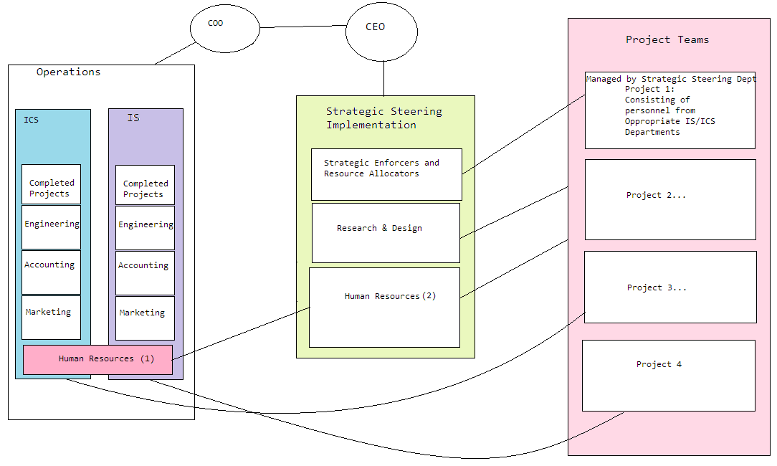Appex should implement a matrix structure with some modifications to counter common pain points. Above is a basic organizational structure, it is not meant to be complete, but rather offer an illustration of the decided course of action. There should be three major departments: Operations, Strategic Steering Department, and Project & Development. Operations would be tasked with current product and services support composed of ICS and IS divisions and within each division, functional teams. There is no head of each operational division rather the COO is head of the entire operations department to mitigate bickering and competition for resources between divisions. The COO will allocate resources as he see’s fit. The COO is constantly weighing the value of currently supported systems and the costs they impose for support.

The Strategic steering Department is made of non-departmental agents that work on behalf of the CEO. Their job is to perform strategic planning and implement chosen strategies in the form of human resources, research & development, and projects & innovation. R&D resides within SSD and seeks out opportunities in alignment with strategies set by the CEO. Human resources reside in both Ops and SSD. Operational HR ensures current products are supported and planned projects do not create gaps when personnel are pulled for projects. The HR under SSD is uniquely positioned for talent acquisition for upcoming technology trends and is charged with pumping personnel into Appex fast enough accommodate customer growth.

The Projects and Development Department is used as an innovation hub, where standard personnel are pulled from regular duties to implement new technologies and services. While on a project personnel would report only to the SSD Project Manager, alleviating the issue of two bosses. After completion of the project the project is assigned to its operation division. The team members of the project are charged with training up personnel within their home dept (such as engineering) on the new system.

**Rejected Alternatives**

**To do nothing**

This is not an option because customers are failing to be served, employees are being paralyzed by fire-fighting the day’s crisis, and there is no true accountability.

**Only Functional**

Functional departments would be implemented in part in each operational division, but to only implement functional departments company wide was rejected. Only using functional structuring would entrench those of similar functions into not seeing big pictures and not working with other departments but would rather put departments at odds with one another as they competed for scarce resources. I do not believe that new technologies are developed well without a complete team structure composed of various departments all working together where the success of the *team* is pinnacle.

**Only Divisional**

Although in the suggested solution divisions are suggested in the operational support side, it would not be suggested to implement divisions company wide.

Divisional structures overemphasize the importance and success of their particular division. Divisions fight one another in an effort to seem more important and do what is best for their division, and not the company as a whole. ICS and IS divisions would create a barrier that doesn't actually exist between the two product lines.

Divisions would help from an operation standpoint, though. When a product is in production and being served to the public it must be supported, and the best way to support a product is to have a committed team that is graded based on product success. This would only be beneficial if newer products were free from the blinders of divisional success, but rather embracing a company strategic success vision.

**Network**

This wasn't chosen because the organization doesn't have any structure or clear delineation of duties as it already is. Adding the necessary relationships would only cloud Appex's ability to know who they are actual accountable to. Appex needs a clear order of accountability, and a network structure would only aggravate the chaos that is being experienced currently.